**Experiment No. 11**

**Aim: Program to Implement Solution using Multiple paradigm**

**Description:**

* The above Java program is a simple **horoscope generator** that prompts the user to enter their birth date in the format "DD/MM/YYYY" and then generates a personalized horoscope based on their zodiac sign.
* The program starts by importing the Scanner and LocalDate classes, which are used to read the user's input and parse the birth date, respectively.
* The main() method begins by creating a Scanner object to read the user's input and then prompts the user to enter their birth date. The input string is then converted to a LocalDate object using the parse() method and the specified date format.
* Next, the program calls the getHoroscope() method and passes the LocalDate object as an argument. The getHoroscope() method uses a series of if statements to determine the user's zodiac sign based on the month and day values of the LocalDate object.
* Finally, the program prints out the user's horoscope by concatenating the string "Your horoscope is: " with the horoscope returned by the getHoroscope() method.

**Source Code:**

import java.util.Scanner;

import java.time.LocalDate;

public class Horoscope {

public static void main(String[] args) {

Scanner input = new Scanner(System.in);

// Get the user's birthday

System.out.print("Enter your birth date (DD/MM/YYYY): ");

String birthdayStr = input.nextLine();

// Convert the birthday string to a LocalDate object

LocalDate birthday = LocalDate.parse(birthdayStr, java.time.format.DateTimeFormatter.ofPattern("dd/MM/yyyy"));

// Get the user's horoscope

String horoscope = getHoroscope(birthday);

// Print the horoscope

System.out.println("Your horoscope is: " + horoscope);

}

public static String getHoroscope(LocalDate birthday) {

// Determine the user's zodiac sign based on their birthday

if (birthday.getMonthValue() == 1 && birthday.getDayOfMonth() >= 20 || birthday.getMonthValue() == 2 && birthday.getDayOfMonth() <= 18) {

return "Aquarius";

} else if (birthday.getMonthValue() == 2 && birthday.getDayOfMonth() >= 19 || birthday.getMonthValue() == 3 && birthday.getDayOfMonth() <= 20) {

return "Pisces";

} else if (birthday.getMonthValue() == 3 && birthday.getDayOfMonth() >= 21 || birthday.getMonthValue() == 4 && birthday.getDayOfMonth() <= 19) {

return "Aries";

} else if (birthday.getMonthValue() == 4 && birthday.getDayOfMonth() >= 20 || birthday.getMonthValue() == 5 && birthday.getDayOfMonth() <= 20) {

return "Taurus";

} else if (birthday.getMonthValue() == 5 && birthday.getDayOfMonth() >= 21 || birthday.getMonthValue() == 6 && birthday.getDayOfMonth() <= 20) {

return "Gemini";

} else if (birthday.getMonthValue() == 6 && birthday.getDayOfMonth() >= 21 || birthday.getMonthValue() == 7 && birthday.getDayOfMonth() <= 22) {

return "Cancer";

} else if (birthday.getMonthValue() == 7 && birthday.getDayOfMonth() >= 23 || birthday.getMonthValue() == 8 && birthday.getDayOfMonth() <= 22) {

return "Leo";

} else if (birthday.getMonthValue() == 8 && birthday.getDayOfMonth() >= 23 || birthday.getMonthValue() == 9 && birthday.getDayOfMonth() <= 22) {

return "Virgo";

} else if (birthday.getMonthValue() == 9 && birthday.getDayOfMonth() >= 23 || birthday.getMonthValue() == 10 && birthday.getDayOfMonth() <= 22) {

return "Libra";

} else if (birthday.getMonthValue() == 10 && birthday.getDayOfMonth() >= 23 || birthday.getMonthValue() == 11 && birthday.getDayOfMonth() <= 21) {

return "Scorpio";

} else if (birthday.getMonthValue() == 11 && birthday.getDayOfMonth() >= 22 || birthday.getMonthValue() == 12 && birthday.getDayOfMonth() <= 21) {

return "Sagittarius";

} else if (birthday.getMonthValue() == 12 && birthday.getDayOfMonth() >= 22 || birthday.getMonthValue() == 1 && birthday.getDayOfMonth() <= 19) {

return "Capricorn";

} else {

return "Invalid birth date";

}

}

}

**Screenshots:**

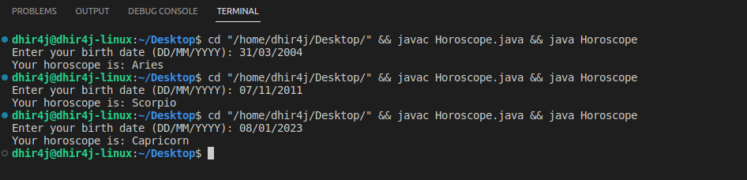

**Conclusion:** Thus, we have created a program to implement solution using multiple paradigm.